**Chrysalis**

This software is for analyzing multispectral 3D images like those acquired on confocal or epifluorescent microscopes as well as two-photon multispectral movies.

This software can be run without owning a copy of Matlab by opening Chrysalis.exe in Windows or Chrysalis in Mac OSX.

For running Chrysalis through Matlab, the computer must have bfmatlab installed.

Installing bfmatlab:

<http://www.openmicroscopy.org/site/support/bio-formats5.2/users/matlab/>

Go to downloads and select matlab toolbox. When downloaded, unzip and copy bfmatlab folder to C:\Program Files. Make sure line 694 in the matlab code for the Chrysalis.m file reflects the location of the bfmatlab folder [addpath (‘C:\Program Files\bfmatlab’);].

**Running Chrysalis:**

This software has only been tested on images saved in Leica’s .lif format, however it supports a wide range of other formats like .tiff and Nikon’s .ND2 format. A complete list of supported formats is here (https://docs.openmicroscopy.org/bio-formats/5.5.3/supported-formats.html).

1. Put all the image files to be analyzed into one folder.

2. If the images will be spectrally unmixed, then use the GenerateCompensationMatrix script and ImageJ to generate a compensation matrix.

3. Start the software by opening Chrysalis.m. Alternatively, open Chrysalis.exe on Windows computers or Chrysalis on Mac.

4. For running Chrysalis in Matlab: Open Matlab, click the editor tab and then click the run button which will make the Chrysalis window appear.

5. In the Chrysalis window, click the “Input folder” button, select the folder containing the image files to be analyzed, click on the “output folder” button, and then select the folder into which the analyzed files will be saved. If spectrally unmixing the images, then click on the “Compensation Matrix” button and select the .sdm file that contains the compensation matrix for the images that will be analyzed. If the image files to be analyzed are in a format other than .lif then change the text in the “file extension” textbox to image’s file format (e.g. .tiff).

6. Select the file type to be analyzed by selecting either movie or 3D image.

7. Select the type of image processing that will be done on the files by selecting any of the options found under image processing (each option is described in detail in the features section below). Once all of the settings for the image analysis are chosen, click the run button in Chrysalis window (not the matlab window) to start the analysis.

**Chrysalis Window with 3D image analysis selected:**

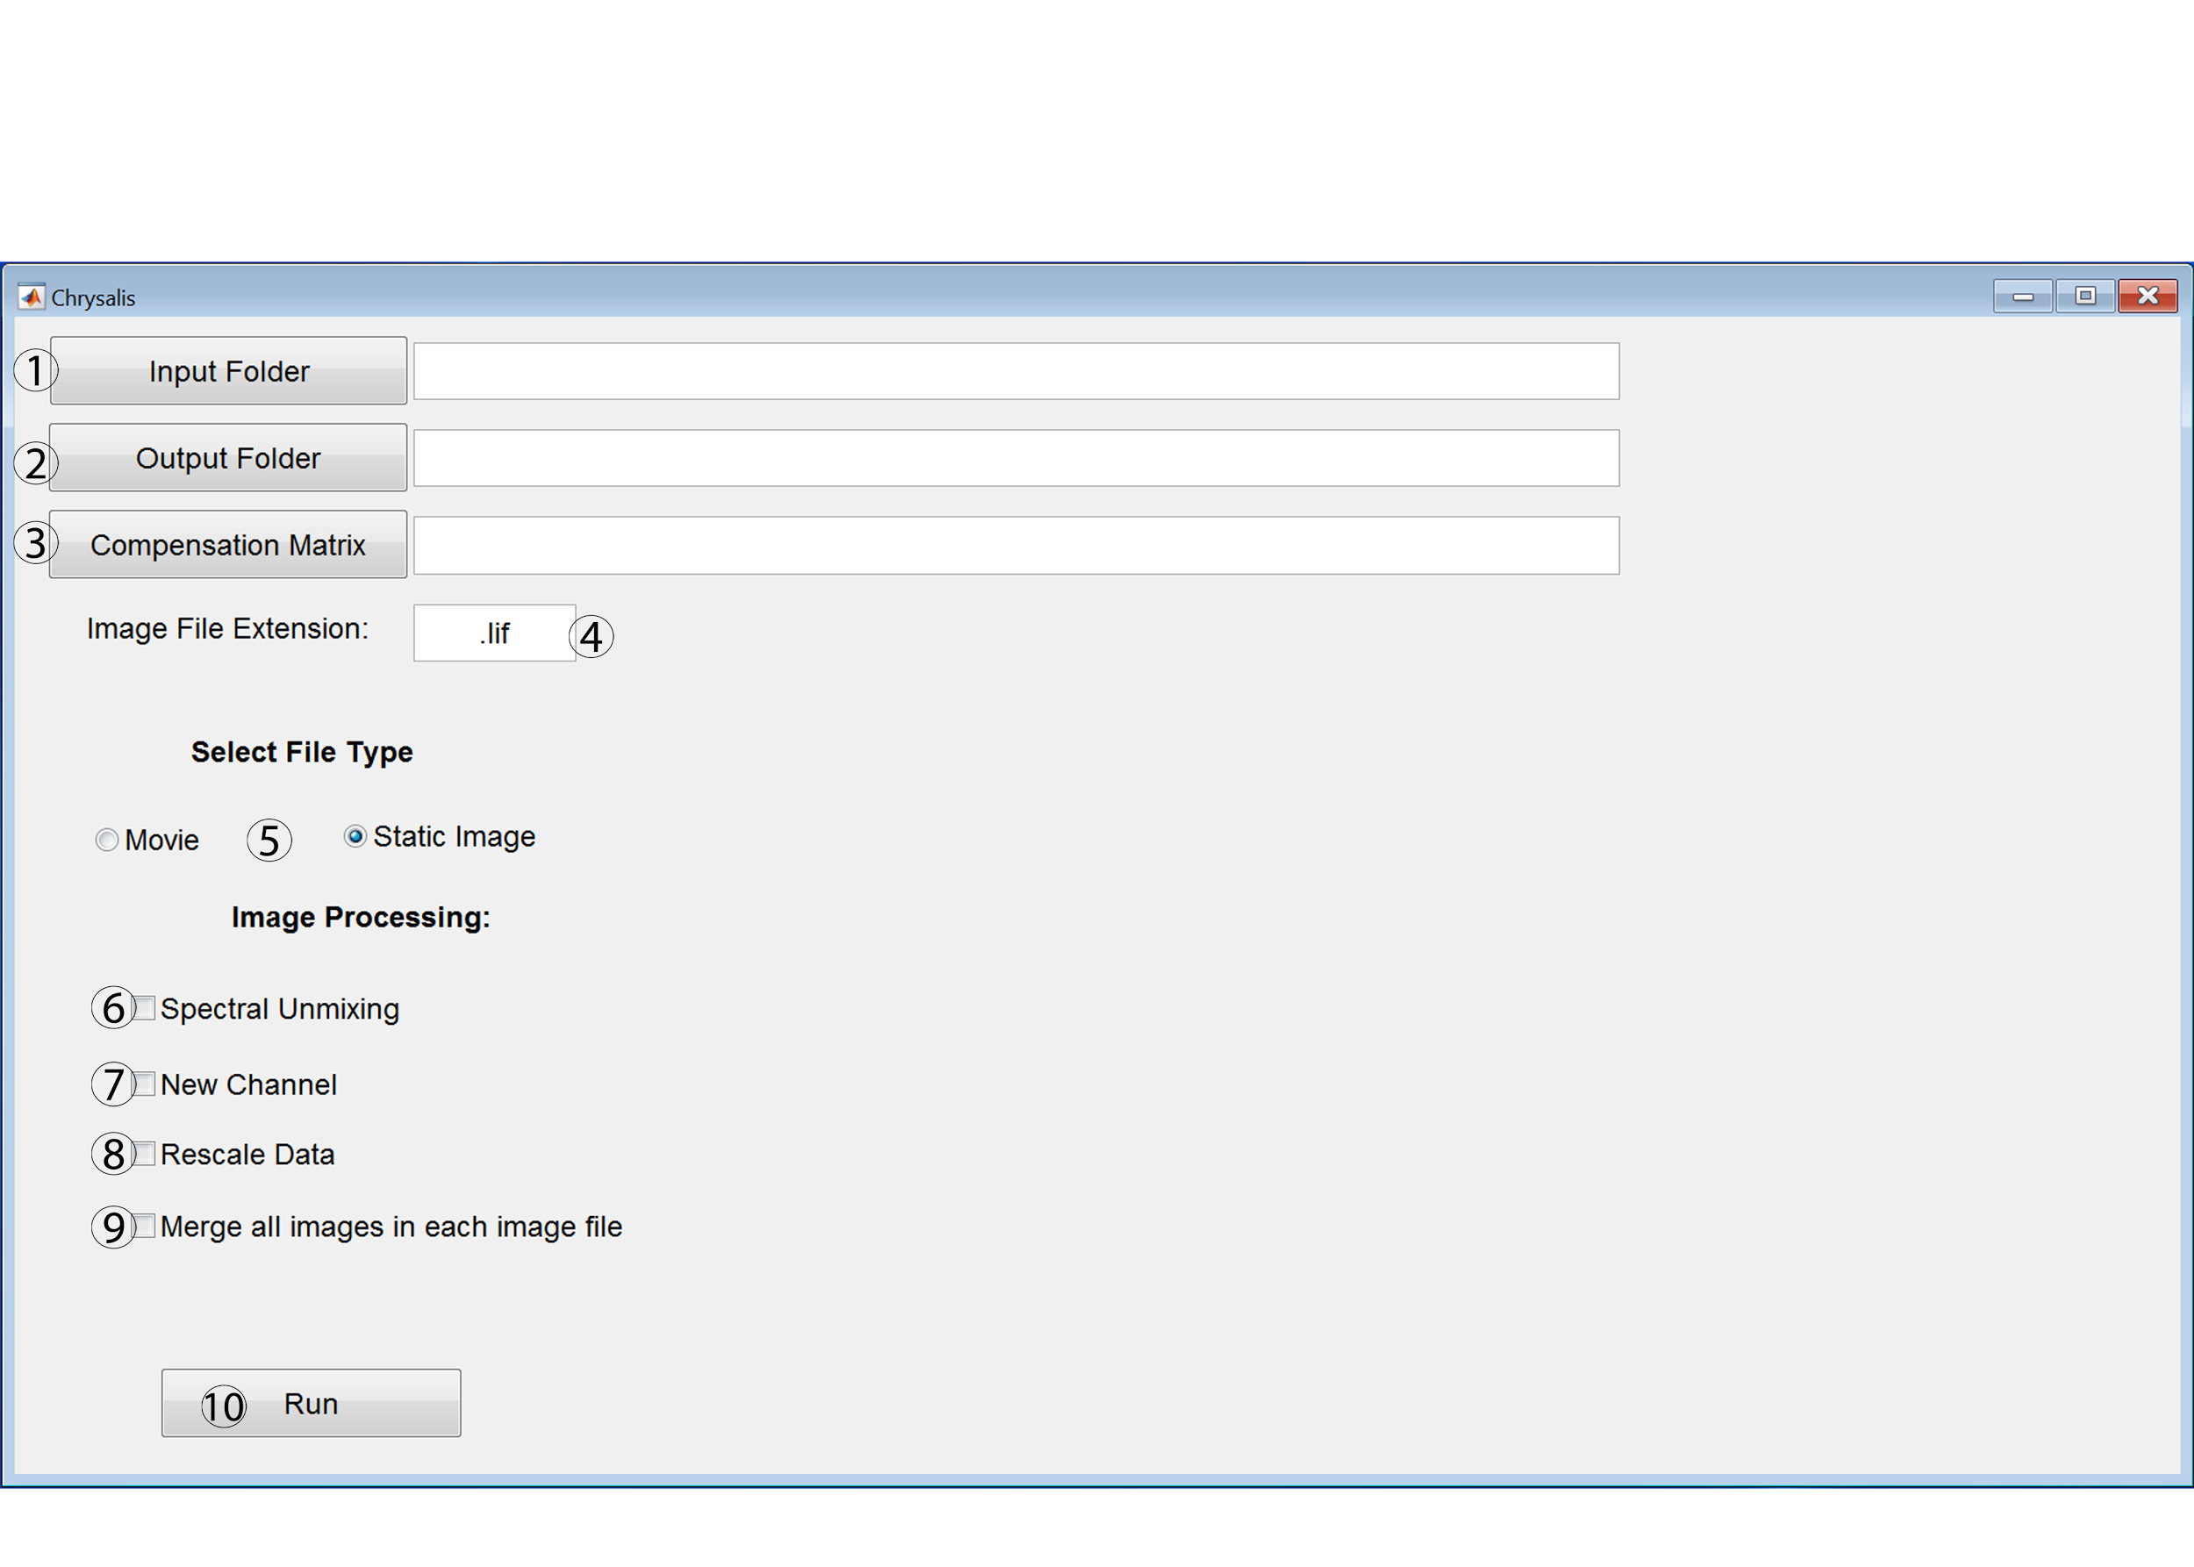

1. Button for selecting the folder that contains the image files that will be processed in Chrysalis. The path for the selected folder will appear in the textbox on the right of the “Input Folder” button and can be edited, if necessary.
2. Button for selecting folder into which image files will be saved after they are processed in Chrysalis. The path for the selected folder will appear in the textbox on the right of the “Output Folder” button and can be edited, if necessary.
3. Button for selecting the compensation matrix file (.sdm file) created with GenerateCompenesationMatrix or Leica Application Suite. The path for the .sdm file will appear in the textbox on the right of the “Compensation Matrix” button and can be edited, if necessary.
4. This textbox states the file extension for the images that will be processed by Chrysalis. The default text is .lif, but this textbox must be edited if a different file format is being used (e.g. if the image files are .ND2 then type “.ND2” in this textbox).
5. Select “Movie” to analyze two-photon microscopy movies or select “Static Image” to analyze 3D images.
6. Select this feature to spectrally unmix images with Chrysalis. This spectral unmixing utilizes the compensation matrix defined by pressing the “Compensation Matrix” button. A compensation matrix must be defined to apply spectral unmixing to images.
7. Select this feature to generate a new channel based on user defined parameters (refer to New Channel Generation in Chrysalis, pg. 22).
8. Select this feature to rescale the data to improve image visualization in Imaris. Selecting this feature is highly recommended.
9. Select this feature to merge every image within an image file (e.g. .lif file) in the z plane. The images will be stacked one after the other.
10. Select this button will process images with Chrysalis based on the parameters selected in this window.

**New Channel Generation in Chrysalis:**

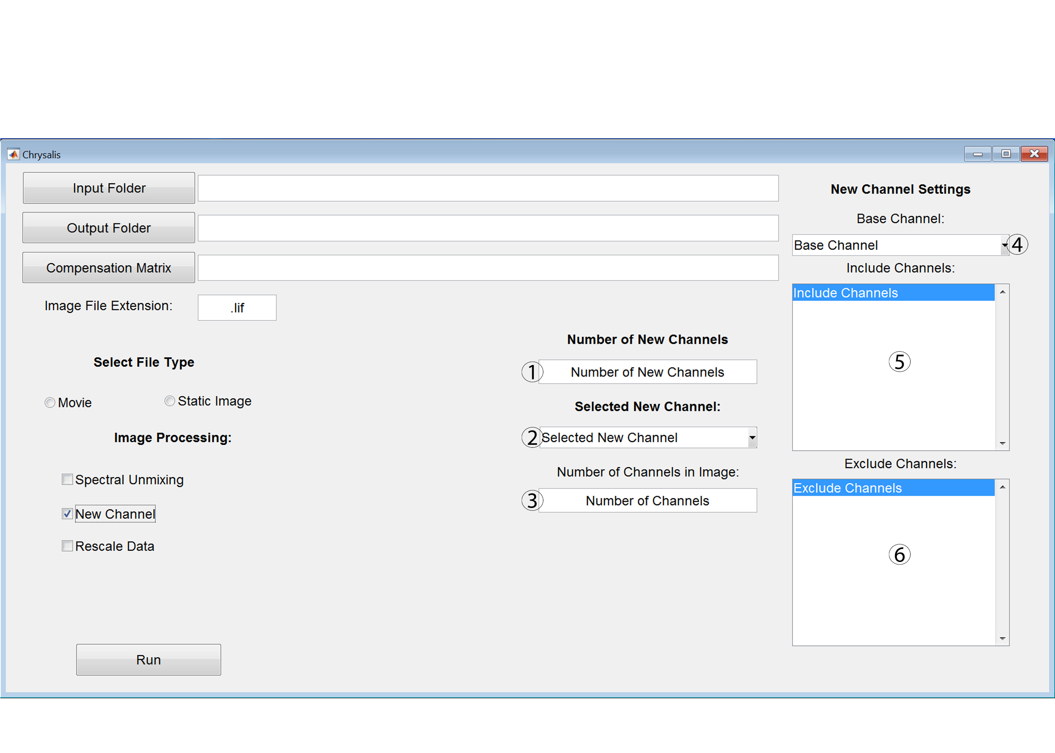

1. In this textbox, type the number of new channels (as a positive integer) that will be generated by the Chrysalis new channel feature.
2. Use this dropdown menu to select between the new channels that will be generated for images processed by Chrysalis.
3. In this textbox, type the number of channels (as a positive integer) that are present in the images that will be processed by Chrysalis. This number does not include the new channels that will be generated by Chrysalis.
4. Use the dropdown menu to select the existing channel that will be used as the base channel for the new channel generated by Chrysalis.
5. Select the channels that will define the inclusion criteria for generating the new channel. Only voxels that are above the threshold of the channels selected in this listbox will be included in the new channel. The threshold is automatically defined by Chrysalis. Multiple options can be selected in the listbox menu by clicking control + left mouse button.
6. Select the channels that will define the exclusion criteria for generating the new channel. Only voxels that are below the threshold of the channels selected in this listbox will be included in the new channel. The threshold is automatically defined by Chrysalis. Multiple options can be selected in the listbox menu by clicking control + left mouse button.

**Save Movie as AVI file in Chrysalis:**

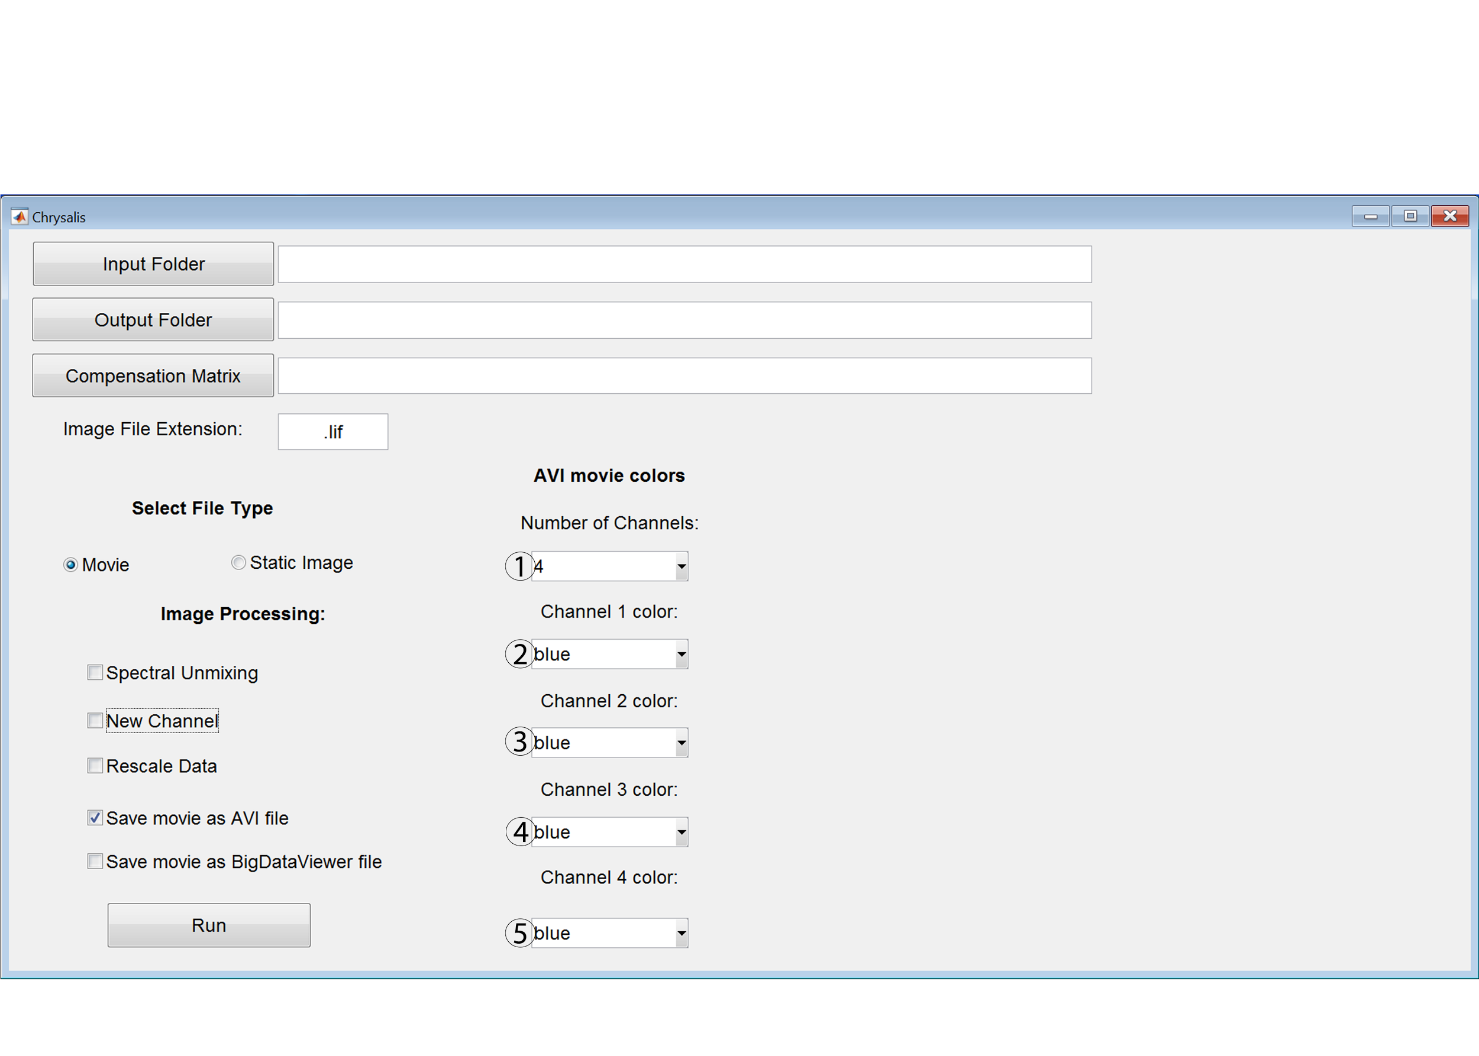

1. Use this dropdown menu to select the number of channels present in the movies that will be processed by Chrysalis. This feature can only be used on movies that have 4 or less channels.
2. Use this dropdown menu to select the color that will be used for channel 1 in the AVI movie.
3. Use this dropdown menu to select the color that will be used for channel 2 in the AVI movie.
4. Use this dropdown menu to select the color that will be used for channel 3 in the AVI movie.
5. Use this dropdown menu to select the color that will be used for channel 4 in the AVI movie.

**Features:**

Spectral Unmixing: Applies linear unmixing to the images based on values in the .sdm file selected as the compensation matrix.

New Channel: Generates a new channel that consists of only voxels that are above the threshold of the channels selected in the include menu and below the threshold of the channels selected in the exclude menu. The signal intensity for the voxels in the new channel is defined as the signal intensity of the user defined base channel. The base channel can be any of the channels in the image. For example, this feature can be used to create a new channel that only contains voxels for DCs by including channels for CD11c and MHCII while excluding channels for B220, F4/80, and CD3 and using CD11c as the base channel.

Multiple options can be selected in the listbox menu of the include and exclude channel menus by clicking control + left mouse button. To generate new channels, enter the number of desired channels that need to be generated into the “number of new channels” text box. Next, select between the new channels using the selected new channel menu. Each new channel can have unique settings (e.g. include, exclude, and base channel), except for the number of channels in the image (specificed in the “Number of Channels” textbox), which needs to be the same for all of the new channels.

When entering values in the “Number of New Channels” and the “Number of Channels” boxes, the value must be a whole number typed as an integer rather than spelled out. For example, enter “1” rather than “one”.

Rescale Data: Rescaling the data is recommended to improve how images appear in Imaris. Rescaling will change the intensity values for each channel to utilize the entirety of the dynamic range. The changes in intensity values after rescaling make it difficult to compare images quantitatively in Flowjo, therefore the rescale factor for each image is exported alongside the image when this feature is selected. This rescale factor file can be used by the XTStatisticsExport and XTChrysalis Xtensions in Imaris to export normalized statistics for each image. This Xtension factors in the rescale factor that was initially applied during processing, thereby providing accurate image to image quantitative comparisons in Flowjo.

When analyzing movies:

Save movie as AVI file: This feature saves the movie as an AVI file. When this option is selected a window appears that allows for color selection for each channel. This option is great for quickly looking over movies to determine which movies have healthy tissue and are worth analyzing further.

Save movie as BigDataViewer file: This feature saves the analyzed movies as a BigDataViewer file, which can be directly opened in Imaris. If this option is not selected, then any spectral unmixing and new channel generation that was performed on the analyzed movies will not be saved.

When analyzing multispectral 3D images:

Merge all images in each file: If the file contains multiple images then selecting this feature will merge all of the images in the Z axis so they are stacked one after the other. This is a great option if a file contains multiple images from one tissue sample. Combining all of the images into one large image allows for the same analysis to be applied to all of the images from one tissue sample and expedites the analysis. Unlike traditional flow cytometry data, histo-cytometry analysis allows each cell to also be analyzed in Flowjo based on its position, cell shape, and distance to other cells.

**After Running the Chrysalis:**

Open the processed files in Imaris by selecting the h5 file for the image when using Imaris 9 or either the XML or h5 file for the image when using Imaris 8. It can take several minutes to open BigDataViewer files directly in Imaris, therefore it may be helpful to convert files into the .ims format with the Imaris fileconverter before opening the images in Imaris.

Upon opening the file in Imaris, the color of each channel can be changed and each channel can be labeled by selecting “image properties” under the “edit” tab.

Processing the images with Chrysalis will change the voxel size of the image leading to inaccurate distance measurements and surface generation. Therefore, while in “image properties”, change the voxel size for X, Y, and Z (found in image properties under the geometry tab) to the image’s original voxel size. The original voxel size can be found by opening the original Leica file in Leica’s LAS X software, right clicking the Leica file, and selecting “properties”. This approach does not work on merged files so use the non-merged version for finding the original voxel size. Upon changing the voxel size, the image might not be visible. In this case, click “fit” and “reset” in the bottom right hand corner of the Imaris window and the image should appear.

**If Matlab has a memory error in the middle of processing images:**

1. Make sure that all possible memory is allocated to Matlab by changing settings for java heap memory (In Matlab, click Preferences then select Matlab then General and then Java Heap Memory).

2. Close Matlab and restart the computer. Log back in and move any processed files out of the input folder specified in Chrysalis. Run Chrysalis again to continue processing files left in the input folder. Closing and opening Matlab without restarting does not always free up the memory.